* **Primitive Type**

|  |  |
| --- | --- |
| **Java Type** | **ANSI SQL Type** |
| byte hoặc java.lang.Short | TINYINT |
| short hoặc java.lang.Short | SMALLINT |
| int hoặc java.lang.Integer | INTEGER |
| long hoặc java.lang.Long | BIGINT |
|  |  |
| float hoặc java.lang.Float | FLOAT |
| double hoặc java.lang.Double | DOUBLE |
|  |  |
| java.math.BigDecimal | NUMERIC |
| java.lang.String | CHAR(1) |
| java.lang.String | VARCHAR |
| boolean hoặc java.lang.Boolean | BIT |
| boolean hoặc java.lang.Boolean | CHAR(1) (‘Y’ hoặc ‘N’) |

VD:

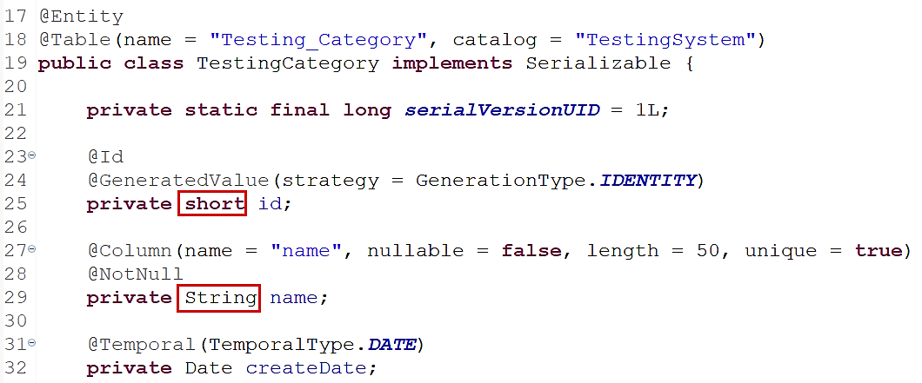

* **Date & Time**

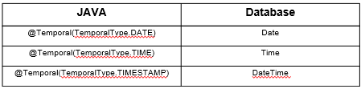

VD1:

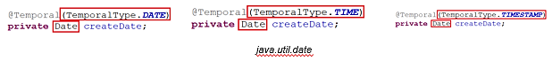

[*https://www.baeldung.com/spring-data-jpa-query-by-date*](https://www.baeldung.com/spring-data-jpa-query-by-date)

VD2: default NOW()

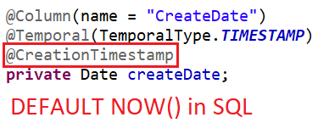

Khi làm việc với Date và time thì nên set timezone cho JDBC

* + Cách 1:

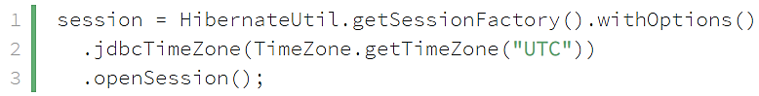

* + Cách 2:

Set hibernate.jdbc.time_zone property trong Hibernate properties

[*https://www.baeldung.com/hibernate-date-time*](https://www.baeldung.com/hibernate-date-time)

* **Reference**

<http://viettuts.vn/hibernate/thuoc-tinh-type-cua-file-mapping-trong-hibernate>

<http://viettuts.vn/hibernate/or-mapping-trong-hibernate>